** **

**Al Imam Mohammad ibn Saud Islamic University**

**College of Computer and Information Sciences**

**Information Systems Department**

**Recycling Page**

**By Group _6_**

Rakan anwar binsamhan, 442020455, 171

Feras Alsaadi, 442020076, 171

Abdullah Almadhi , 443014855, 171

**Bader Nasser Alodhaylah, 443013983 , 171**

Project Submitted in Fulfillment for the [IS337] Course requirements

First Semester, 202425

**Table of Contents**

**1. Introduction................................................................................................1**

**2. Welcome page..........…...............................................................................2**

**3. Sign up page…………….................................................................................3**

**4. Sign in page…............................................................................................6**

**5. Recycling Portal………….............................................................................7**

**6. Conclusions..............................................................................................8**

**Appendix.......................................................................................................9**

**Introduction**

Write the description of the mission and the requirements of this web site.

**Recyclers** is platform designed to Recycling for a Better Tomorrow, we are committed to creating a sustainable future through responsible waste management and recycling practices. With over a decade of experience in the recycling industry, we aim to reduce environmental impact by transforming waste into valuable resources.

**Mission**  
The mission of the **Recyclers** website is to:

* Promote eco-friendly behavior by enabling users to easily locate recycling centers, schedule pickups, and track their waste contributions.
* Foster a community of environmentally conscious individuals and organizations working together to reduce waste and promote sustainability.
* Provide educational resources and updates on recycling practices, trends, and technologies to raise awareness on environmental issues.

### Requirements

For the website to achieve its mission, the following features and functionalities are essential:

1. **User Authentication**:
   * Secure sign-up and login system allowing users to create accounts
   * Ability to reset passwords
2. **Recycling Center Locator**:
   * Integration of a map feature to allow users to find nearby recycling centers.
3. **Educational Resources**:
   * A dedicated section for articles, videos, and tips on recycling best practices and environmental conservation.
   * Updates on new recycling technologies and policies.
4. **Community Engagement**:
   * Forums or discussion boards where users can exchange ideas, share their experiences, and collaborate on environmental initiatives.
   * Events and campaigns to encourage group recycling efforts.
5. **Mobile-Friendly and Accessible**:
   * Responsive design that works well across devices, including mobile phones and tablets.

**Requirements Screenshots**

Provide all the screenshots answering requirements

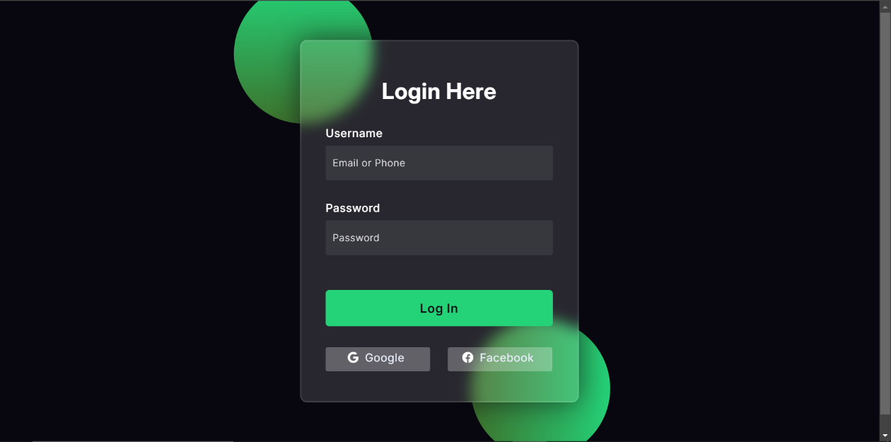

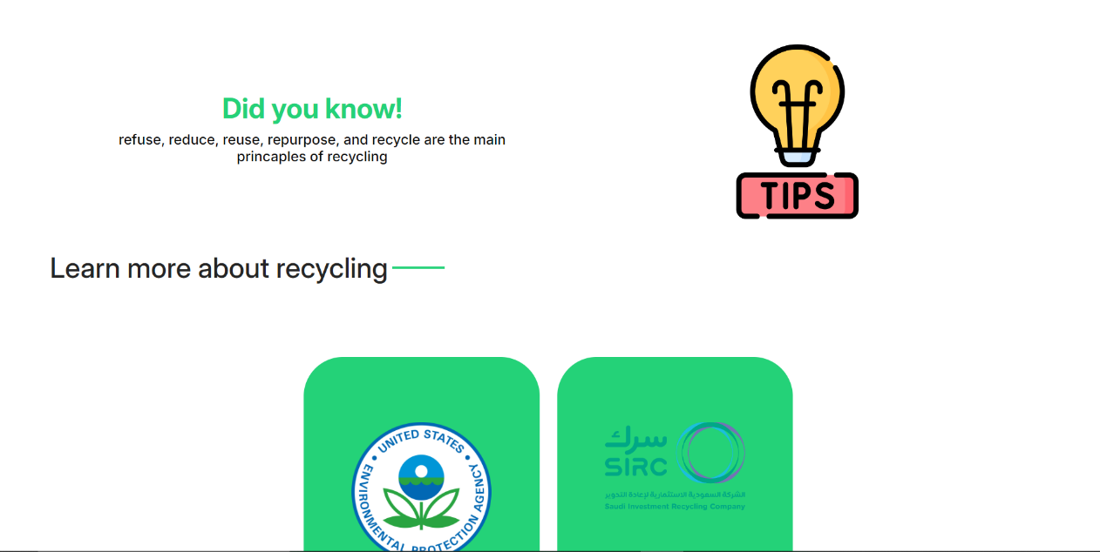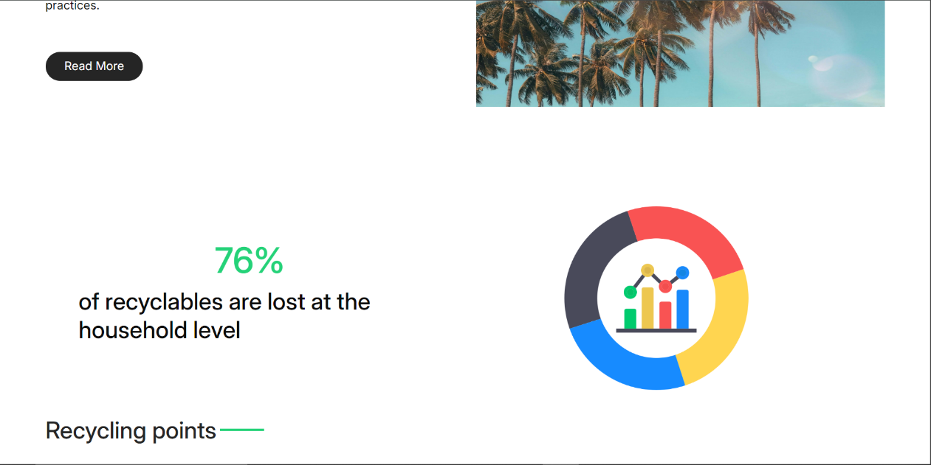

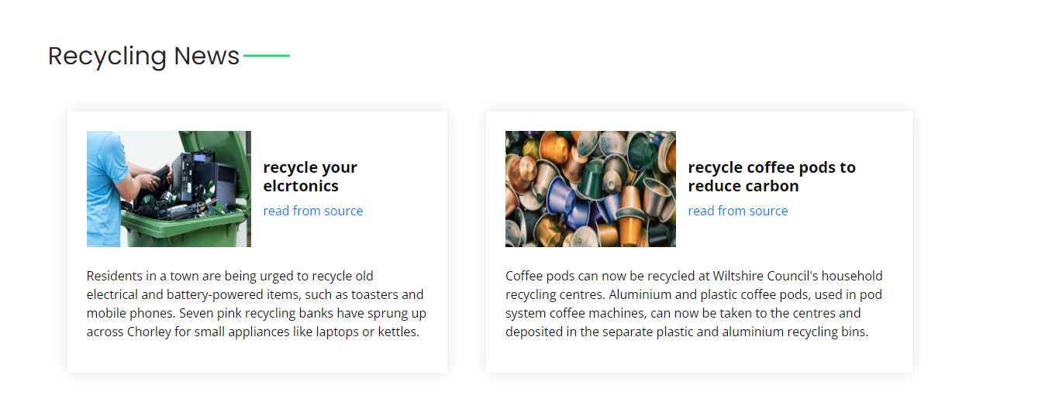

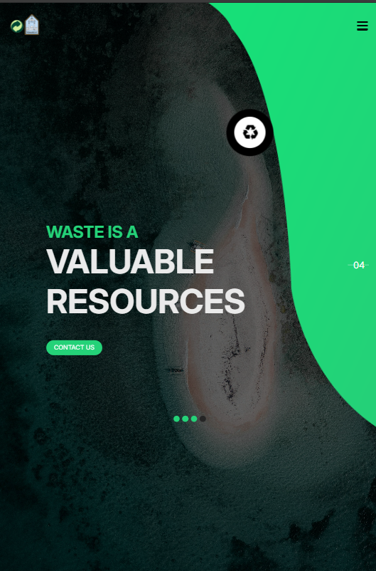

**Conclusions**

This **Recyclers** web page serves as a comprehensive and user-friendly platform for student members, empowering them to actively participate in environmental sustainability efforts. By providing features like easy registration, recycling center locators, pickup scheduling, contribution tracking, and educational resources, it creates a space where students can engage in eco-friendly practices, track their impact, and collaborate with like-minded individuals. The platform's mobile responsiveness and accessibility ensure that students can interact with the site from any device, making recycling more convenient and impactful.

To achieve the final goal of this project, we utilized the following technologies:

* **HTML5** for structuring content and ensuring semantic and accessible web pages.
* **CSS3** and **Bootstrap 4** for responsive and modern UI design, ensuring a mobile-friendly and visually appealing experience.
* **JavaScript** and **jQuery** for interactive elements, enhancing user engagement and providing real-time functionality such as form validation and dynamic map updates.
* **Google Maps API** for integrating the recycling center locator feature, allowing users to easily find nearby centers.

**APPENDIX**

Give HTML and CSS important pieces from your own code that you think important

HTML:

1. **Meta Tags for Responsiveness:**

<meta name="viewport" content="width=device-width, initial-scale=1, shrink-to-fit=no" />

Ensures the page is mobile-friendly and adjusts based on different screen sizes.

1. Navbar**:**

<header class="header_section">

<!-- Navbar code with logo, navigation links, sign-in option -->

</header>

This section structures the navigation of the website and ensures usability across various pages.

1. Hero **Section (Slider):**

<section class="slider_section">

<!-- Carousel for rotating images and important messages -->

</section>

This contains the carousel that displays the project's key information and encourages user engagement.

CSS:

1- Responsiveness**:** The use of @media queries ensures that the layout adjusts properly for mobile, tablet, and desktop views.

@media (max-width: 768px) {

.hero_area { padding: 30px 15px; }}

2-Carousel **Styling:**

.carousel-inner .carousel-item {

transition: transform 1s ease-in-out;}

3- Button **Styling:**

.btn-1, .btn-2 {

padding: 10px 25px;

background-color: #28a745;

color: white; }